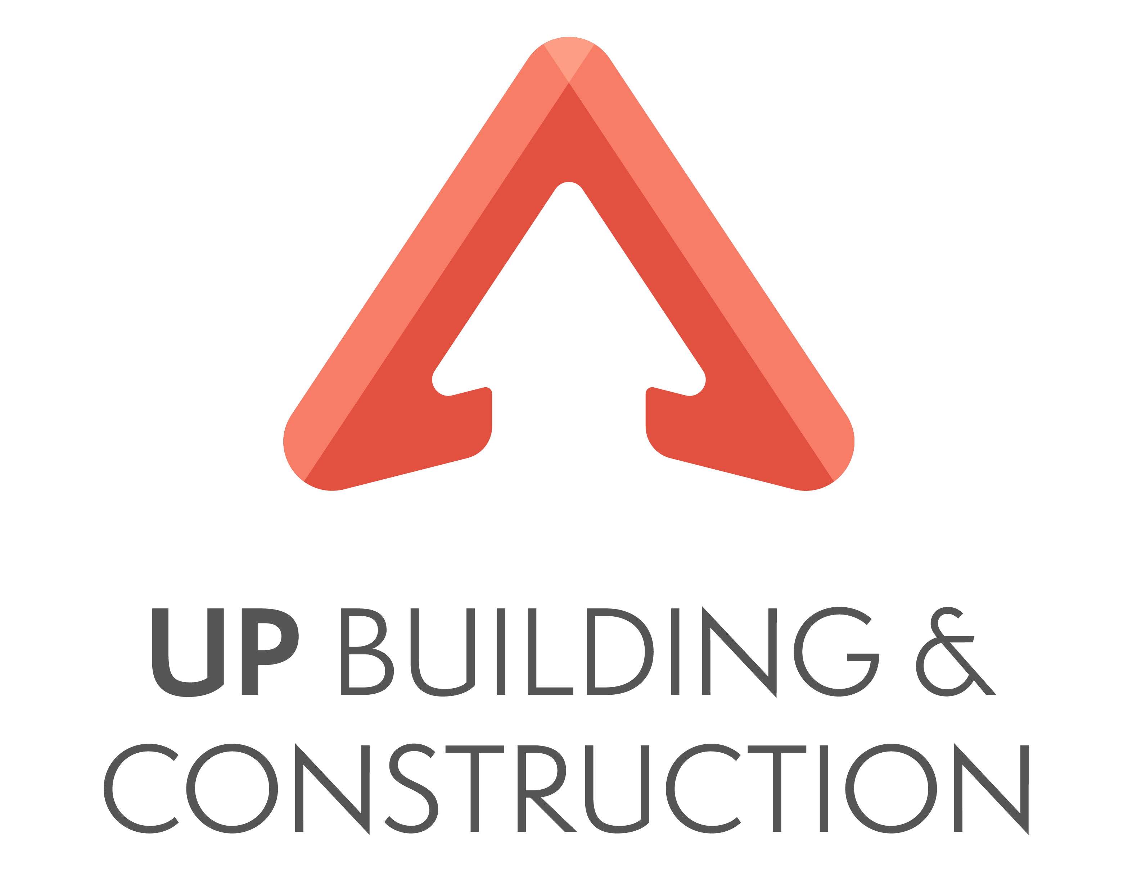
UP Building and Construction Pty Ltd
“Building dreams from the ground UP”
ABN 123 456 789

Contents
UP Building and Construction: Safe Design 1
1. Safe design principles 1
2. A safe design approach 3
3. Ergonomics and good work design 3
4. Product lifecycle 3
5. Environmental requirements 4
6. Creating / reviewing building and construction plans 4
7. Confirm compliance of construction plan information 5

UP Building and Construction: Safe Design

1. Safe design principles
UP Building and Construction is dedicated to ensuring the health and safety of all employees and clients. In addition to the detailed Work Health and Safety procedures that were developed in accordance with the Work Health and Safety Code of Practice and Safe Work Australia’s safety guidelines, safe design guidelines are re-enforcing the integration of hazard identification and risk assessments methods early in the design process, to eliminate or minimise risks of injury throughout the life of a product. This applies to buildings, structures, equipment and vehicles.
UP Building and Construction ensures that an appointed expert team reviews all designs and their intended purpose and actively contribute to the decision making on how safe design can be achieved.
Principle 1: Persons with control—those who make decisions affecting the design of products, facilities or processes are able to promote health and safety at the source.
Principle 2: Product lifecycle—safe design applies to every stage in the lifecycle from conception through to disposal. It involves eliminating hazards or minimising risks as early in the lifecycle as possible.
Principle 3: Systematic risk management—apply hazard identification, risk assessment and risk control processes to achieve safe design.
Principle 4: Safe design knowledge and capability—should be either demonstrated or acquired by those who control design.
Principle 5: Information transfer—effective communication and documentation of design and risk control information amongst everyone involved in the phases of the lifecycle is essential for the safe design approach.
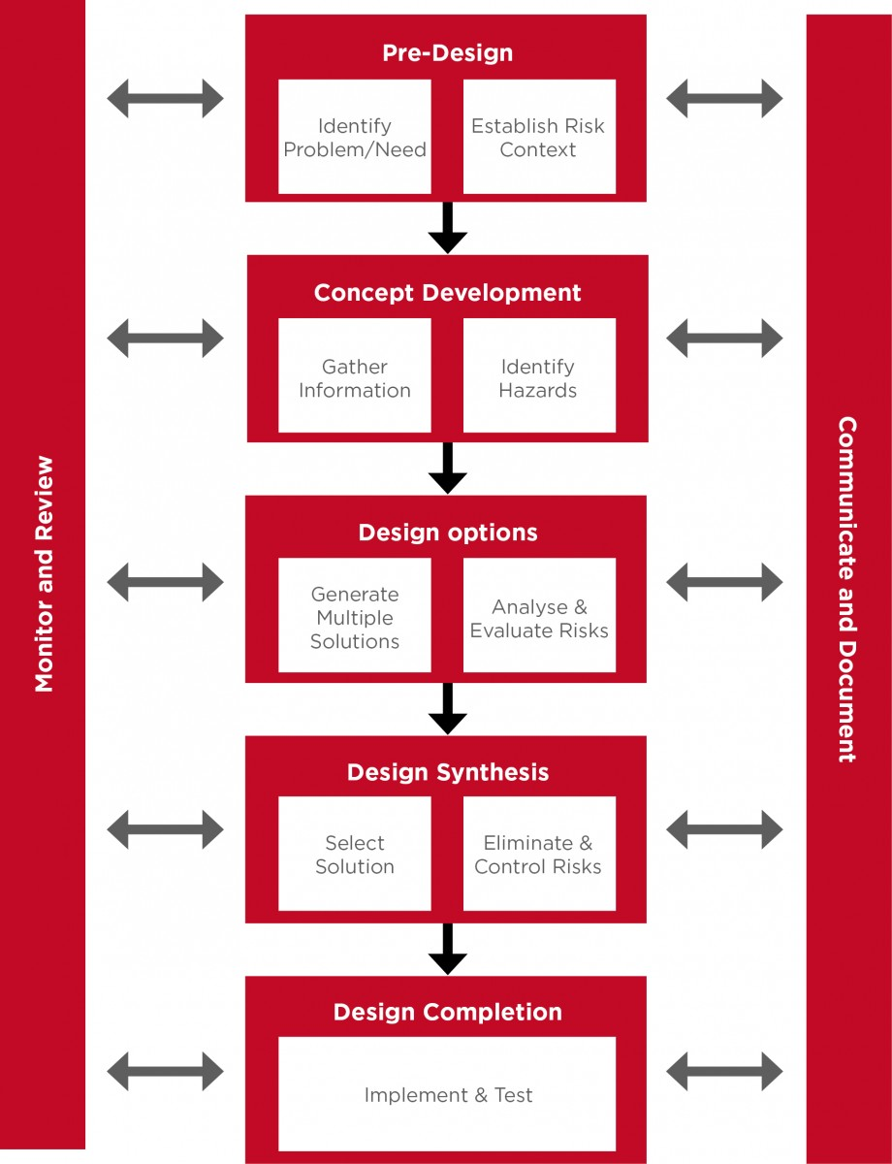
Safe design, © Safe Work Australia

2. A safe design approach
Safe design begins at the concept development phase of a structure when making decisions about:
- the design and its intended purpose
- materials to be used
- possible methods of construction, maintenance, operation, demolition or dismantling and disposal
- what legislation, codes of practice and standards need to be considered and complied with.

UP Building and Construction achieves safe design by:

- Pre-design – at this stage, design needs and problem areas are identified while establishing the context for risk management for the whole design process.
- Concept development – information is gathered, including information on potential hazards in the designs.
- Design options – multiple options for designs are reviewed while risks (associated with the hazards identified previously) are analysed and evaluated.
- Design synthesis – a final design option is selected. It is also at this stage where risks are eliminated and mitigated.
- Design completion – the design is executed and tested and reviewed regularly.

Up Building and Construction takes prides for engaging architects who have a solid understanding of the National Building Code (NCC) and their practices align with the performance requirements found in the NCC.

3. Ergonomics and good work design
Safe design incorporates ergonomics principles as well as good work design.
- Good work design helps ensure workplace hazards and risks are eliminated or minimised so all workers remain healthy and safe at work. It can involve the design of work, workstations, operational procedures, computer systems or manufacturing processes.

4. Product lifecycle
The lifecycle of a product is a key concept of sustainable and safe design. It provides a framework for eliminating the hazards at the design stage and/or controlling the risk as the product is:
- constructed or manufactured
- imported, supplied or installed
- commissioned, used or operated
- maintained, repaired, cleaned, and/or modified
- de-commissioned, demolished and/or dismantled
- disposed of or recycled.

Designers must have a good understanding of the lifecycle of the item they are designing, including the needs of users and the environment in which that item may be used.

5. Environmental requirements
UP Building and Construction is dedicated to follow sustainable building principles throughout all projects, ensuring compliance with relevant environmental national and state legislation and regulations. This includes planning during concept development phase of a structure with the use of sustainable materials, innovative techniques and energy efficient building solutions to achieve safe designs and to minimise ecological footprint during building phase as well as during maintenance.
For more details regarding environmental requirements please consult the Environmental and Waste Management Policy and Procedures.

6. Creating / reviewing building and construction plans
UP Building and Construction prepares building and construction plans using AutoCAD, ArchiCAD, Revit and Sketchup. Alternative software and/or 3D models and 2D plans may be used at the discretion of the architect in charge, in consultation with senior management and clients.
UP Building and Construction generally produces the following types of construction documents:

- Site Plan
- Floor Plans (General arrangement, Concrete set-out, fit-out, etc)
- Roof Plan
- Reflected Ceiling Plans
- Sections
- Elevations
- Internal elevations
- Details (Stair Details, Wall details, waterproofing details etc)
- Signages / Wayfinding strategy plan

Generally, when preparing and creating a building construction plan, UP Building and Construction follows the following steps:

- Submit initial files - Client provides conceptual set, any previous completed and approved set of plans, sketches with the relevant CAD documentation (if available).
- Evaluate scope of work - Organisation evaluates the scope of work and provide deadlines and budget for the project.
- Implement project – the building construction plans are prepared and submitted for review
- Conduct quality checks and rectifications – any feedback, corrections are implemented.
- Final delivery – building construction plans are finalised and handed over.

7. Confirm compliance of construction plan information
To confirm compliance of construction plan information with building and construction regulations, standards, and codes:
- Access and review the building and construction plans of the project you are undertaking.
- Note down all building and construction requirements which are:
- The building regulations applicable in your state/territory
- The Australian standards related to building and construction drawings
- The requirements of the NCC, including requirements relating to:
- Fire safety
- Health and amenity
- Safe movement and access
- Energy efficiency
- Assess the building and construction plans you have against the requirements mentioned in Step 2. You can do this by checking/marking items that are compliant with the requirements and noting / marking up those items which are non-compliant.
- Provide supporting statements or explanations as to why the construction plans comply or did not comply with the requirements indicated.

